1. First, consider the social and task ties as separate networks.

(A) Use igraph to generate indegree, outdegree, closeness, betweenness, and PageRank centrality statistics for each individual the social and task networks.

Social:











Task:

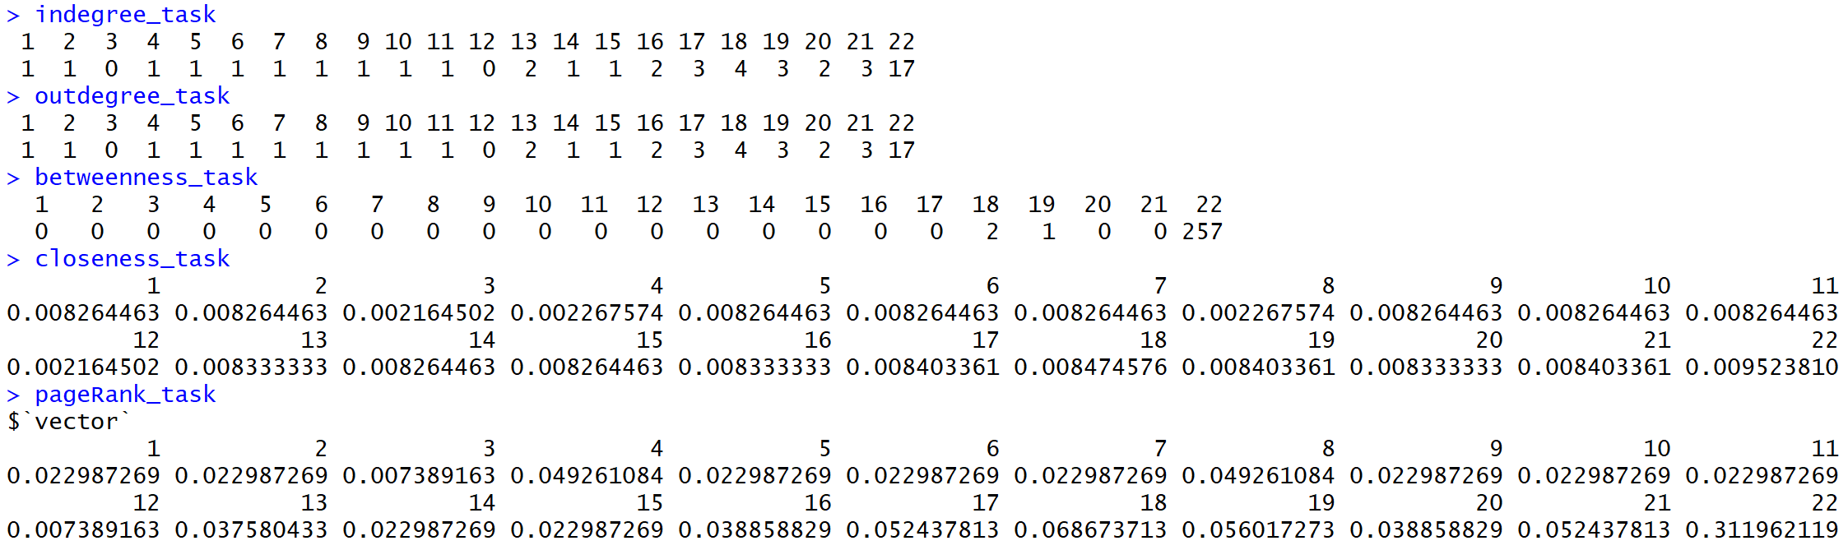

(B) Compute the correlations of the ﬁve centrality measures you generate for the social network with the ﬁve measures generated for the task network. Which measures in the task network are most closely related to those in the socializing network? Name at least one insight can you draw from the relationships between these ﬁve measures across the two networks.

Betweenness has highest correlation. Page Rank has lowest corelation

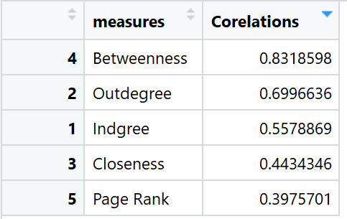

After combing two graphs in one graph the final graph we get is as below.

Blue = Social Tie

Red = Task Tie

Green = Both social and task tie

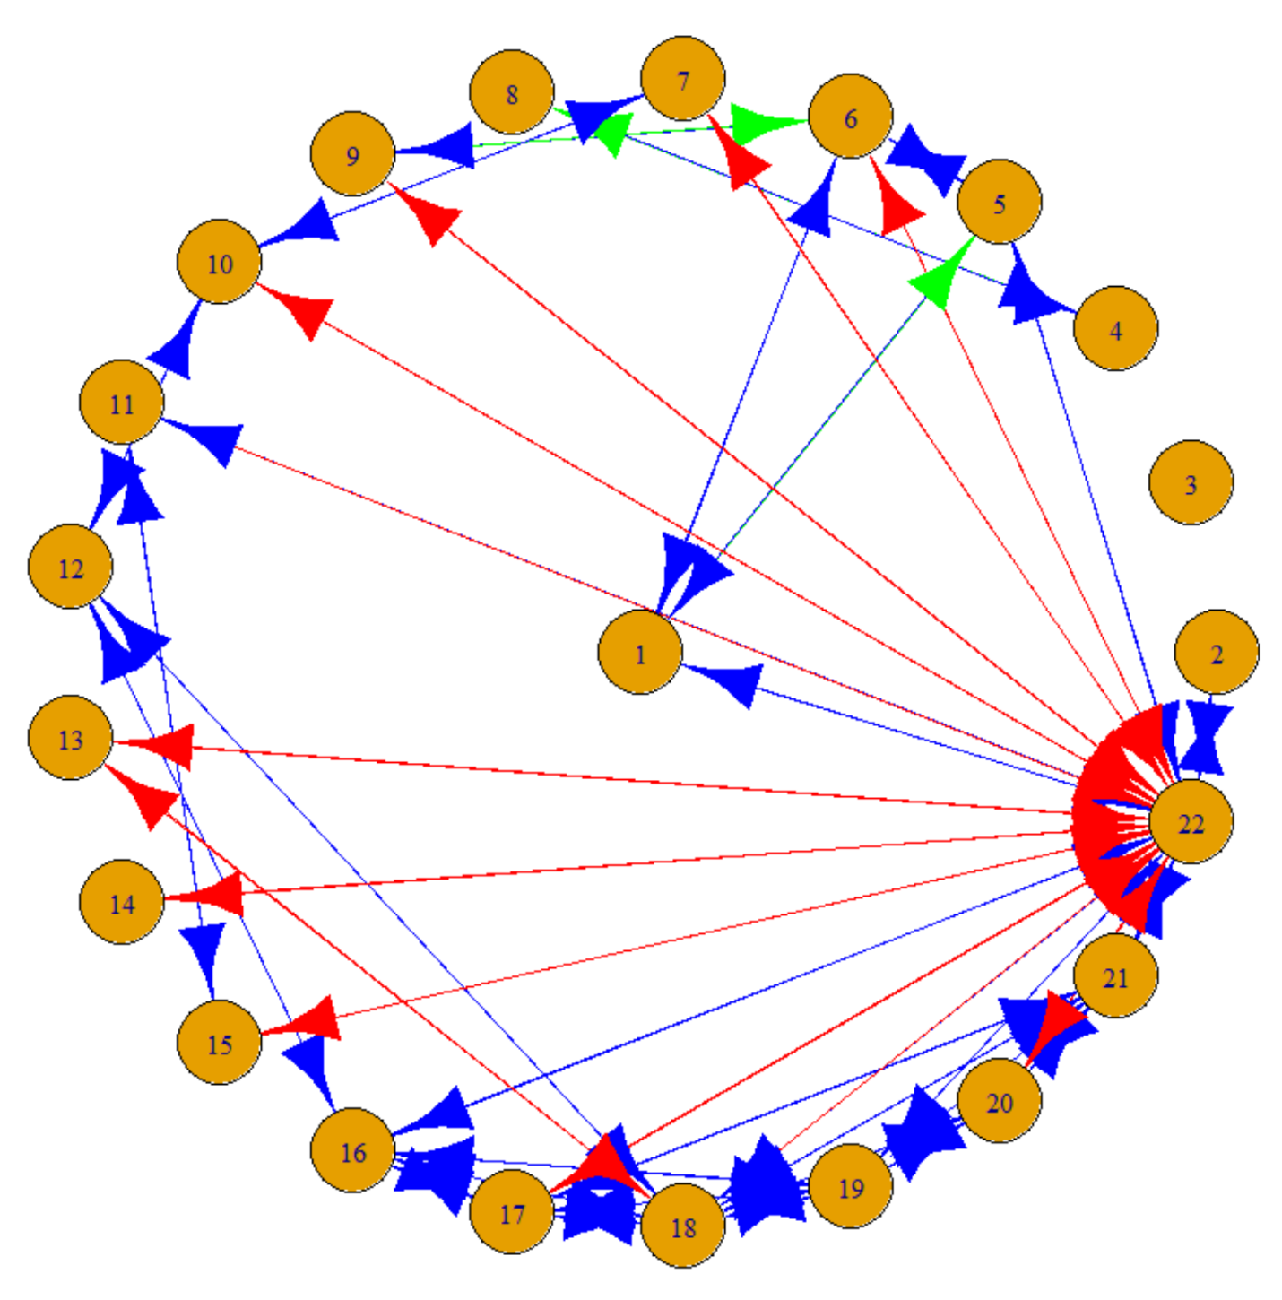

I have considered **undirected graphs for answers below**. Logic of creating edge weights while combining the edges is as below. For both social and task tie, Maximum value from the in or out is considered as the weight of the edge.

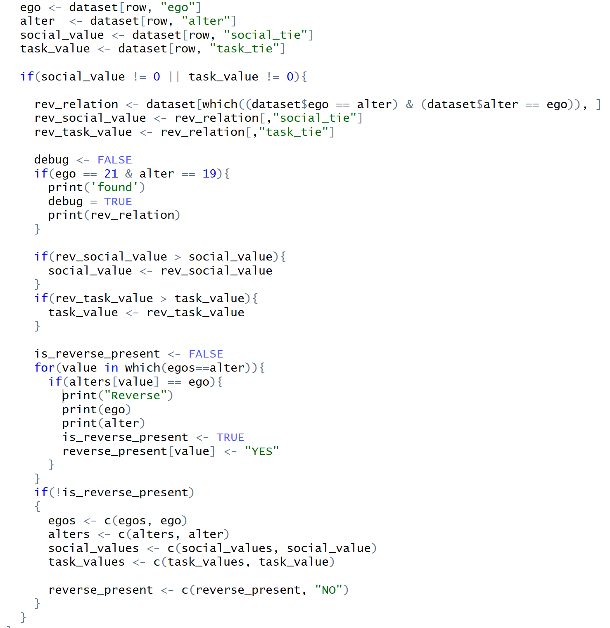

**2**. Next, consider the social and task ties together, as two distinct types of ties comprising one network.

For the sake of simplicity, I have cleaned the dataframe to have values of tie maximum if reverse relation exists. Below is the cleaned data frame.

(A) Suppose that a tie is strong if it is above the mean strength for that type, conditional on the tie existing—do not include weights of 0 in the calculation of the mean. Under this deﬁnition, does the network satisfy Strong Triadic Closure? Come up with a solution that illustrates this (1) visually, in a plot, as well as (2) programmatically, by giving the number or proportion of ties that are violation of Strong Triadic Closure.

(B) Now suppose that a tie is strong if it is above the median strength for that type, conditional on the tie existing. Under this deﬁnition, does the network satisfy Strong Triadic Closure? What insights does this illustrate about these interactions within the network?





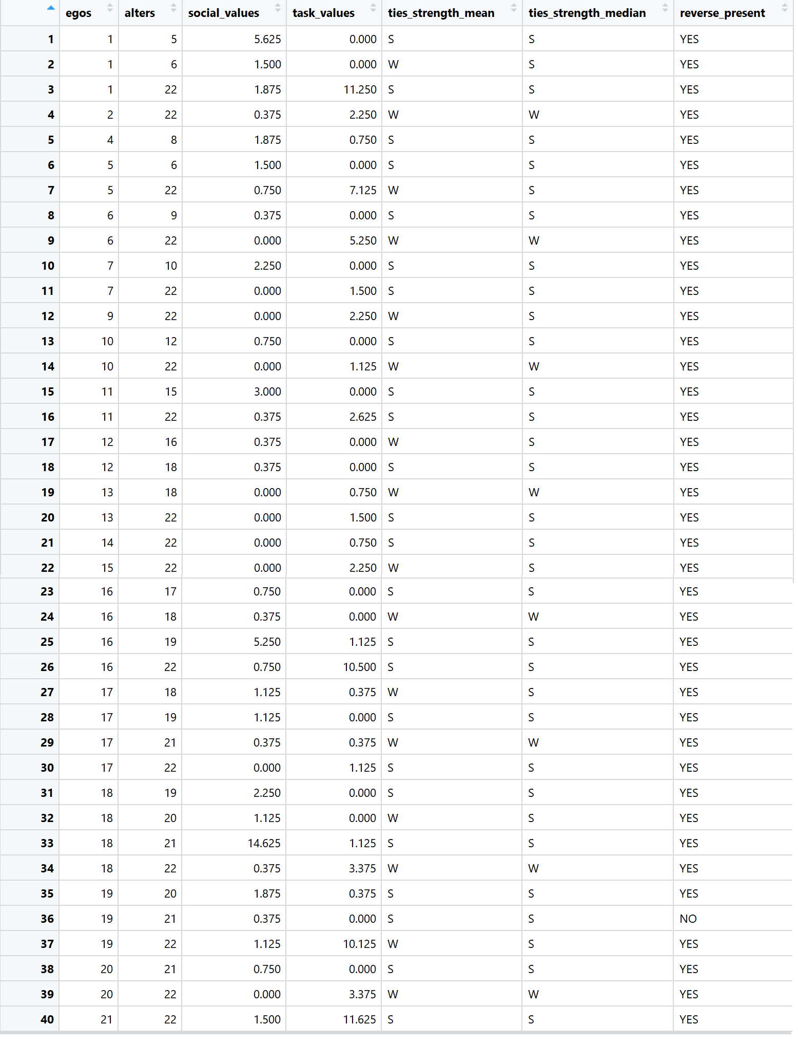

USING MEAN AS CUTOFF

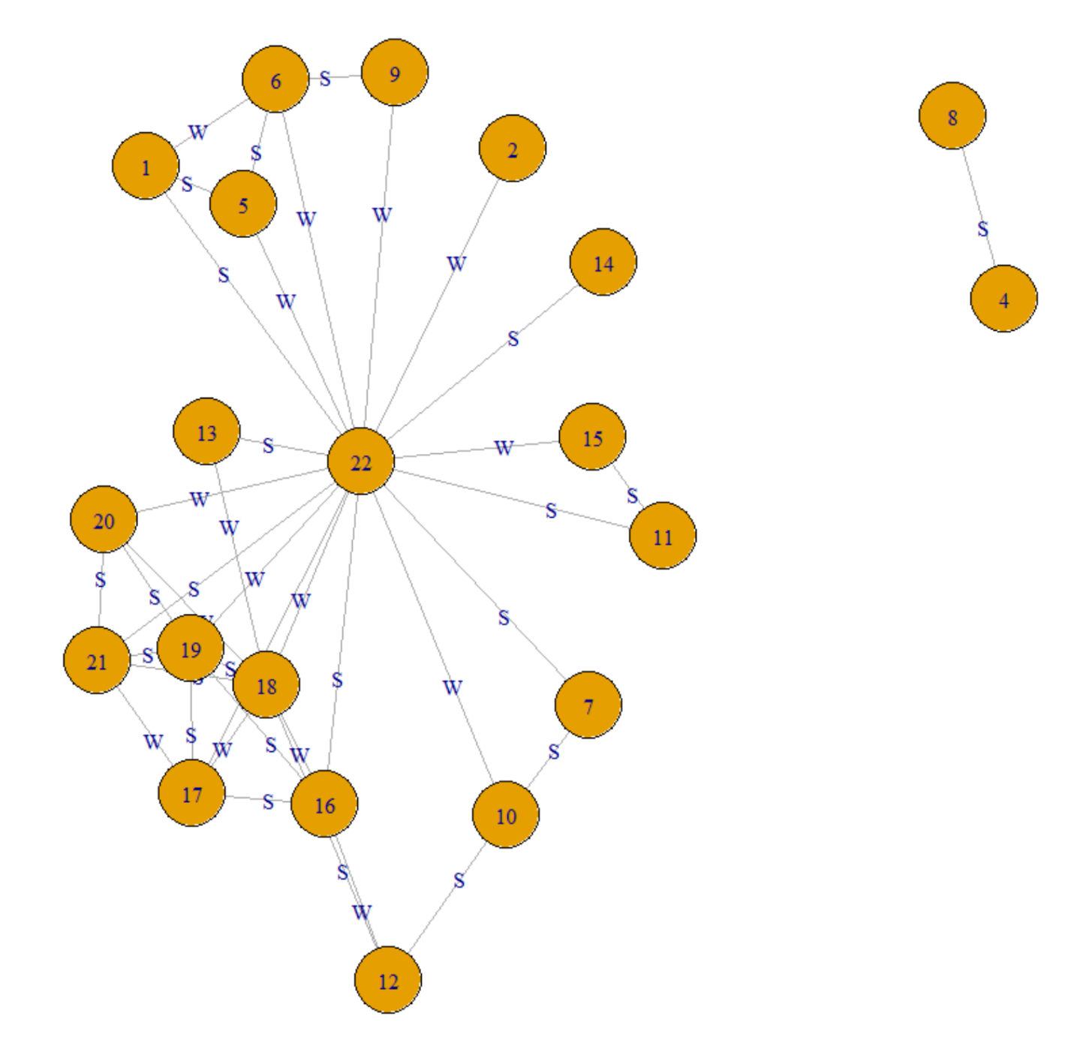

Some of the violations of strong triads are triangles = 22-7-14, 22 – 16 - 1

USING MEDIAN AS CUTOFF

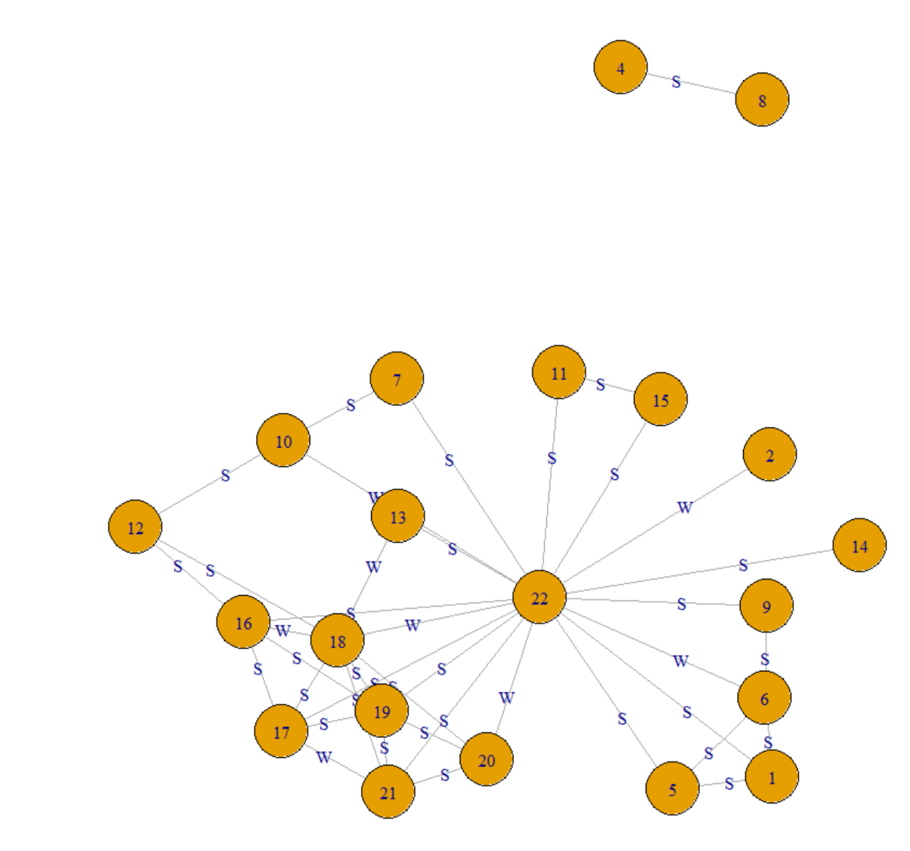

Some of the violations of strong triads are triangles = 22-11-5, 22 – 7 - 11

**3**. Continue to treat the social and task ties as two distinct ties comprising one network.

(A) It is also possible to compute betweenness on the edges in a network, as well as the vertices. This is a good measure of the ﬂow of information and resources through a network. Calculate the edge-level betweenness for both of the types of tie.

Yes it is possible to calculate edge level and vertex level betweenness.

SOCIAL UNDIRECTED GRAPH

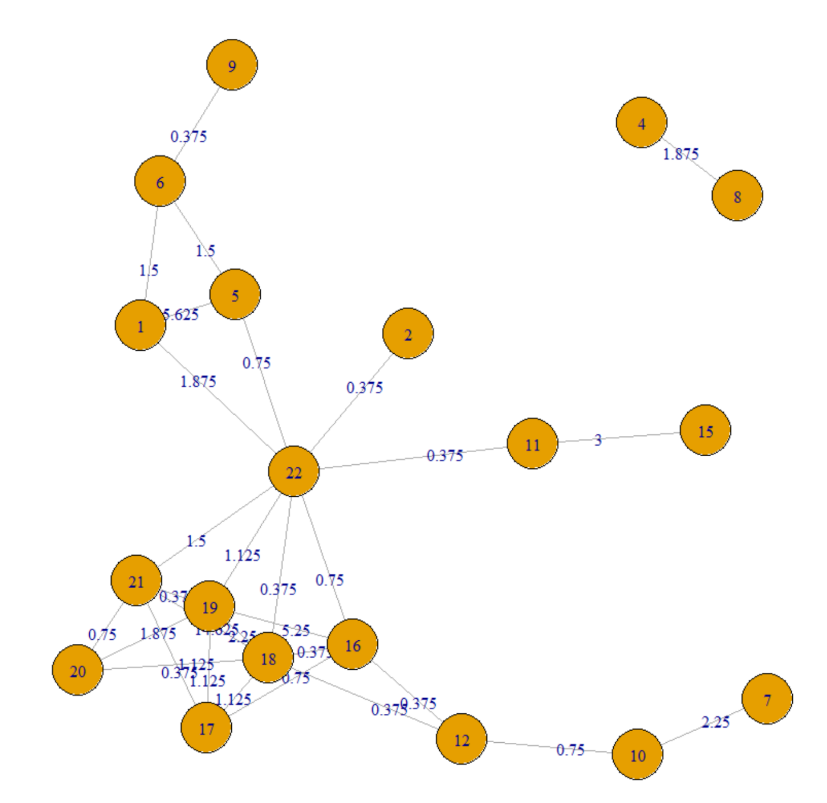

TASK UNDIRECTED GRAPH

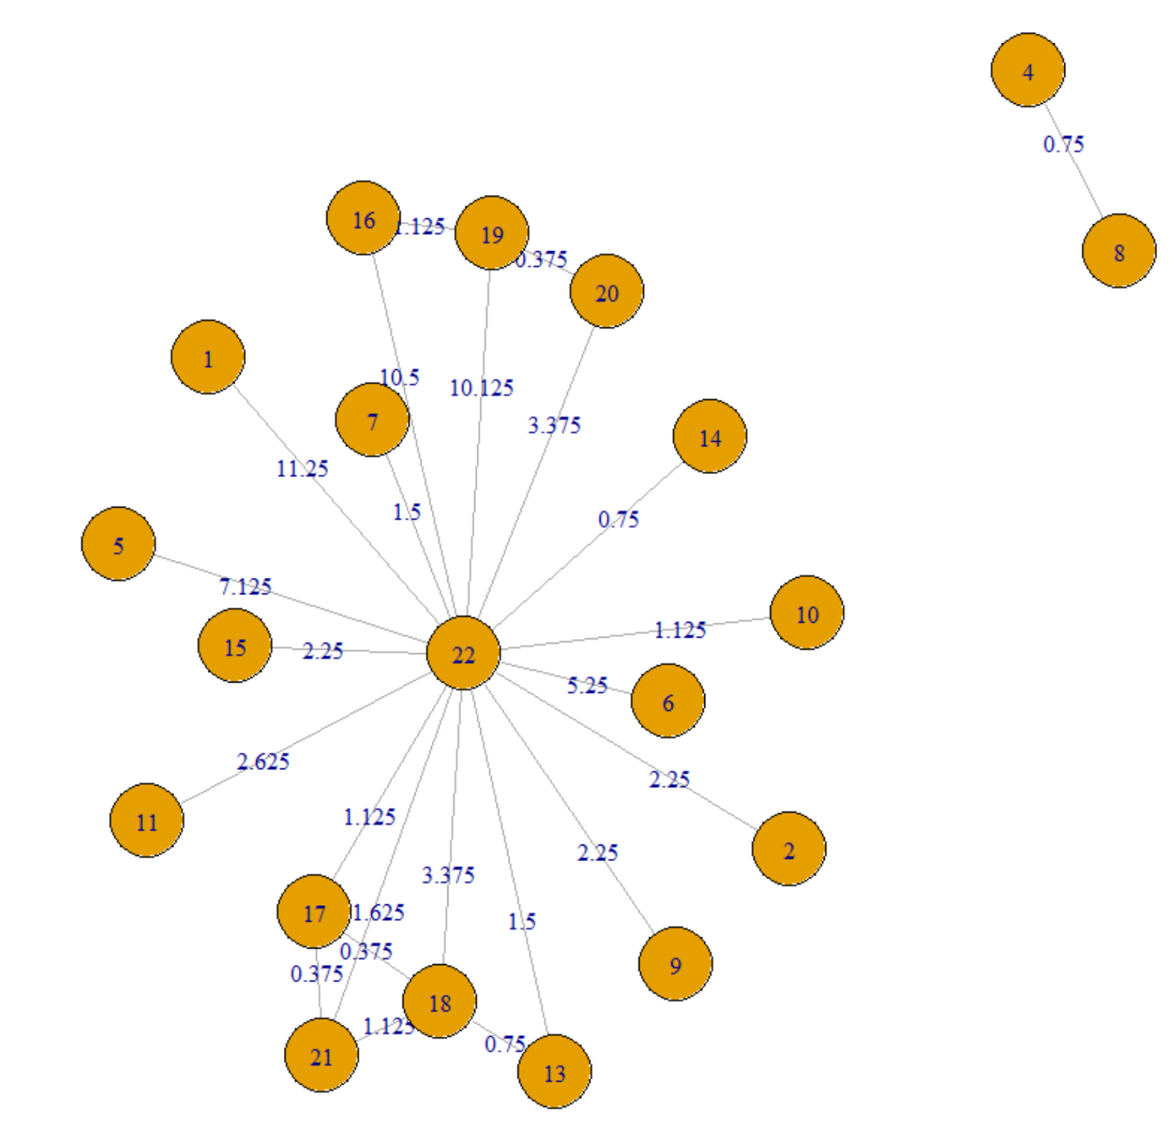

(B) Does it seem like edges with high betweenness tend to be strong or weak ties, according to our two deﬁnitions above? Does this result make sense?

SOCIAL TIES GRAPH EDGEWISE BETWEENNESS

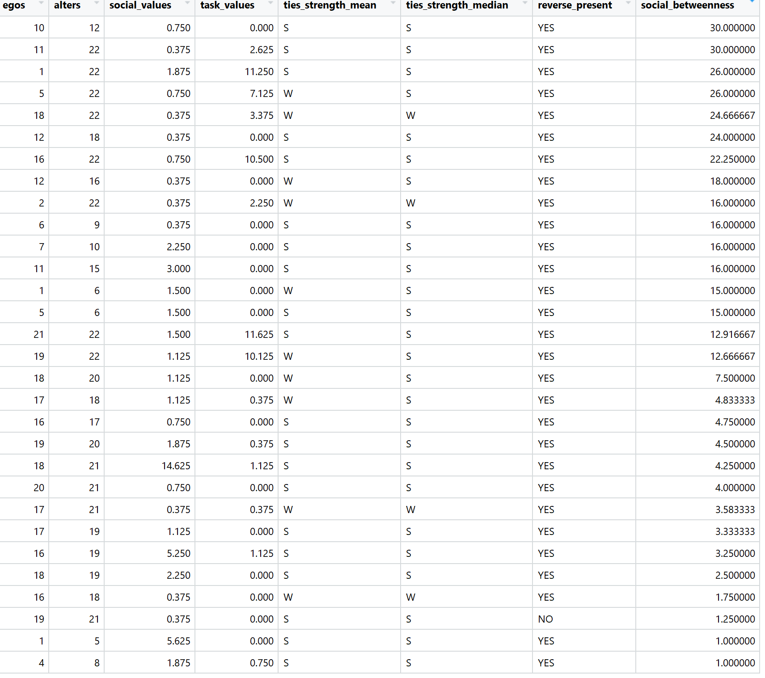

TASK TIES GRAPH EDGEWISE BETWEENNESS

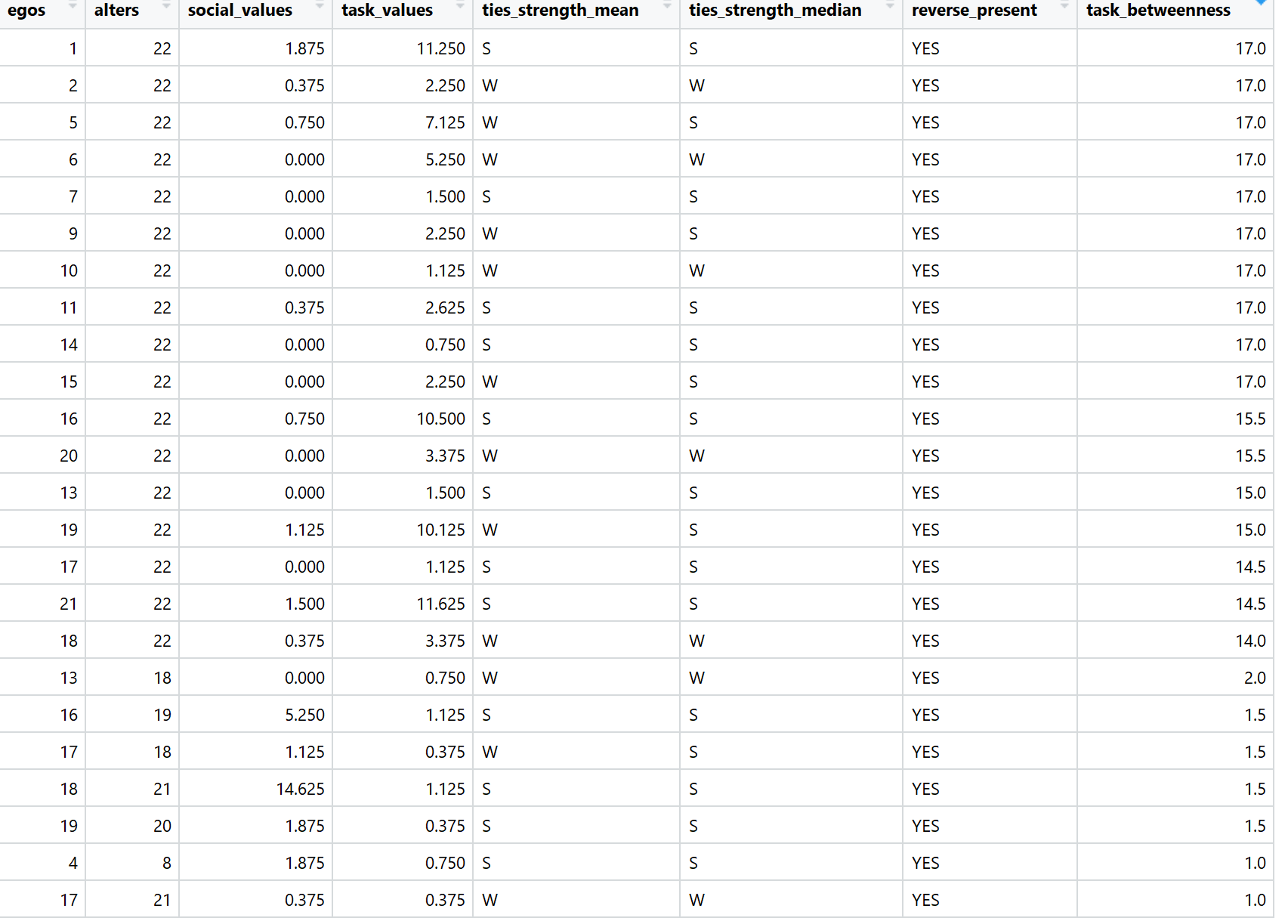

The strength depends on the cutoff value set. Looking at above two tables we can not say if high betweenness yields to strong or weak ties.

**4**. Continue to treat the social and task ties as two distinct ties comprising one network. How many pairs of nodes do not have walks between one another? Find a solution that performs this calculation directly on the matrix—it is possible to verify this solution via igraph afterward.

Since we have consider the ties as two distinct but in one network, that means if social tie is present one way but task tie is present other way still we say that the tie is both ways.

I have already coded the logic to find edges that do not have reverse relations also present. The edge marked as red is the one that does not have reverse relation all others have a reverse relation present.

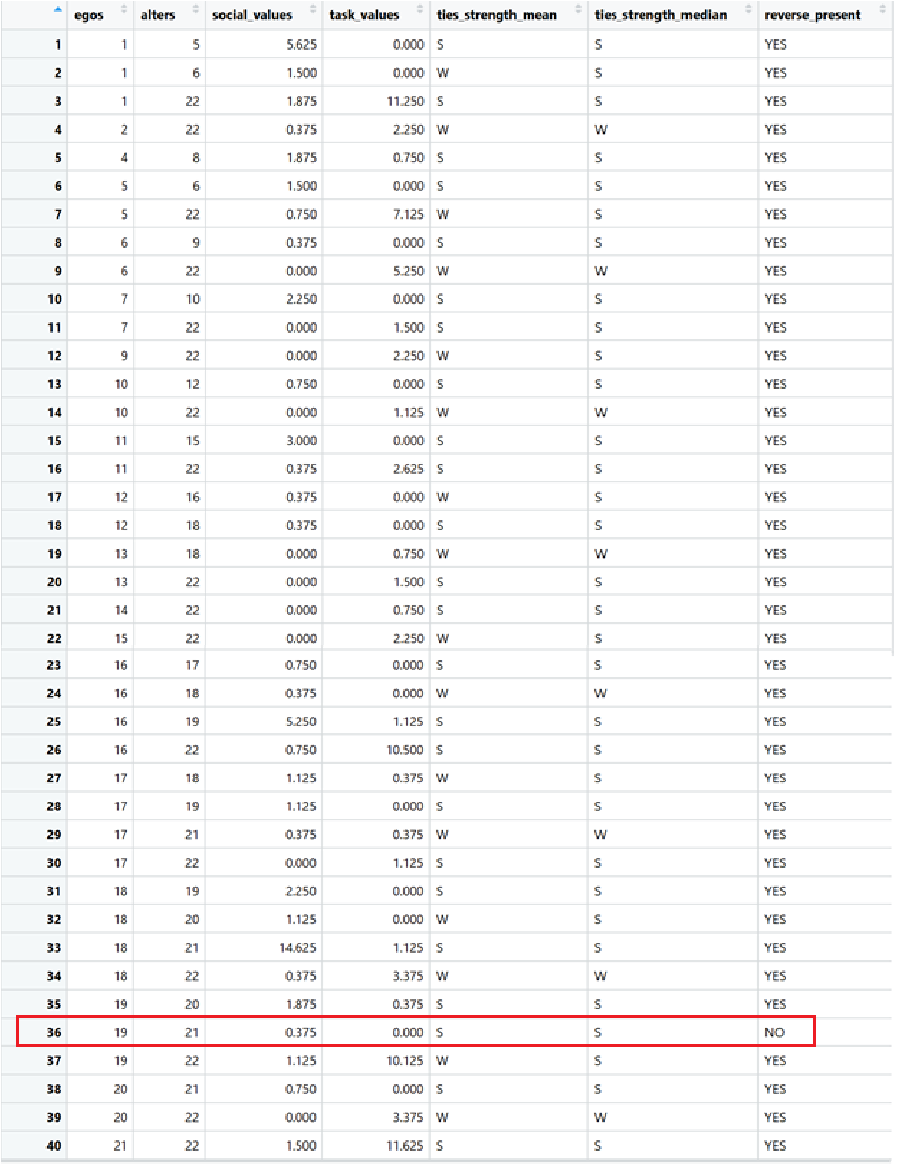

**5**. The network-level measure of degree centrality is a good indicator of the dispersion of the degreedistributioninanetwork. GenerateandplotanetworkinRinwhichthenetwork-level measure of degree centrality, is equal to 1, and another where it is equal to 0. Would this relationship hold true for other measures of centrality, such as closeness or betweenness?

I have considered undirected graph for this example.

For network level degree centrality to be **1:** All the vertices should be connected to central node and no other node

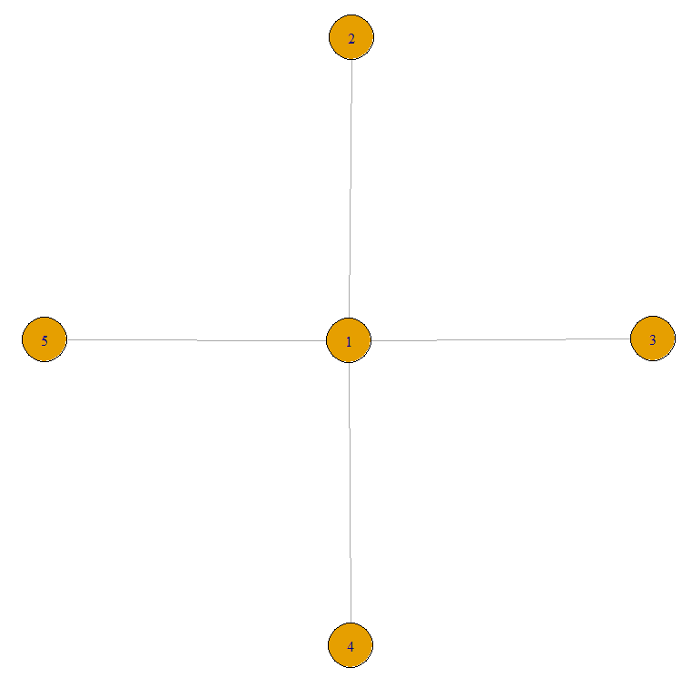

All the vertices have degree as 1, except for central with degree as 3. Hence from the formula given in question the Network level degree centrality = **1**

For network level degree centrality to be **0:** All the vertices should be connected to each other.

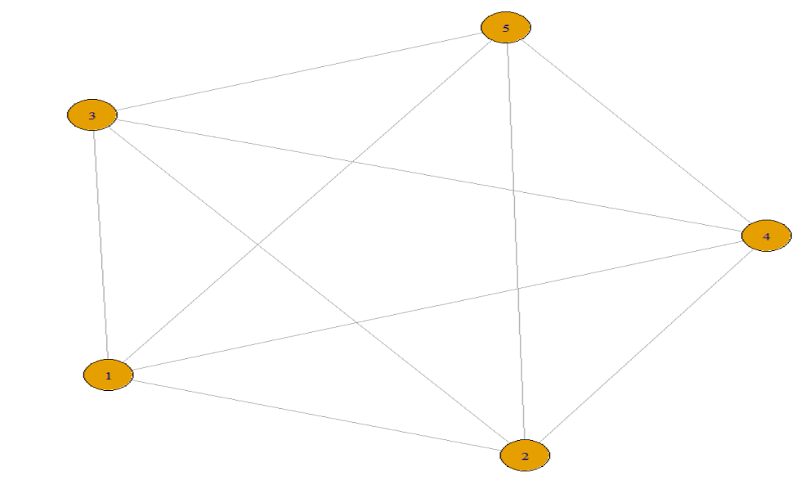

All the vertices have degree as 4. Hence from the formula given in question the Network level degree centrality = **0**

Histogram shows degree distribution after scaling the values(degrees) to between 0 to 1 is

